Typography
Dokumentation · 2026-10-30 · https://groovy.simplo.dev/typography
This is a short description
Note
Quark 2 is Grav 2.0's default theme. It uses Blades CSS (the actively maintained successor to Pico CSS) as a classless foundation, layered with a Cal.com-inspired design system. Full Blades capabilities are documented in the Official Blades CSS Docs.

Buttons and icon links
Open the settings when you like, or use the icon alone: Installation.
Get started Read the guides Typography

Headings
Quark 2 uses Cal Sans for display headings and treats h1 / h2 distinctly — h1 sits at a lighter display weight while h2 is bolder and gains a small accent bar to mark section breaks. h6 is rendered as an uppercase eyebrow label.
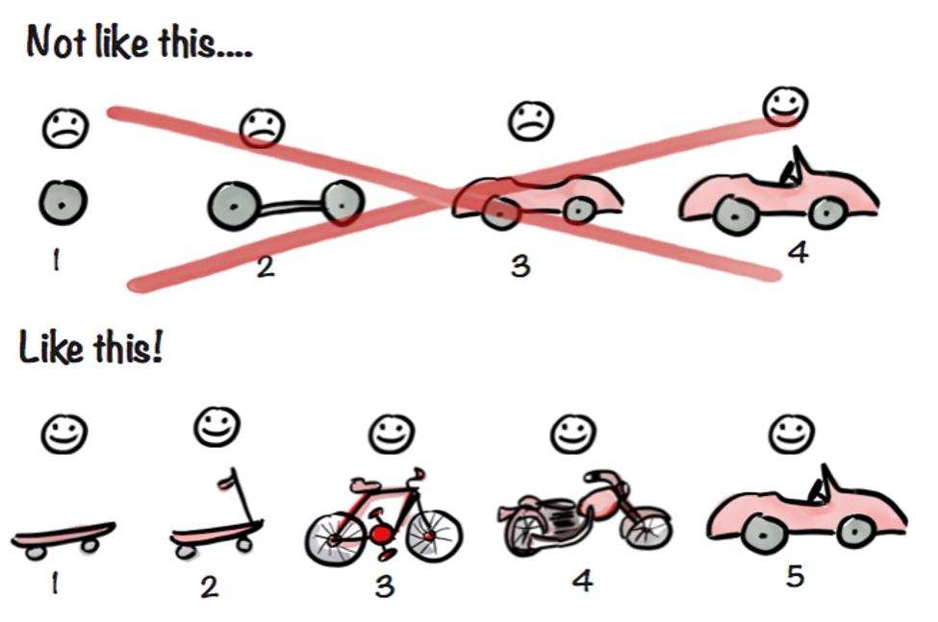

Images: shadow and icons in the text
An image on a line with text is an icon: click  to read more. It is as high as the line, without border or shadow.

H1 Heading — airy, display weight

H2 Heading — confident, with accent bar

H3 Heading — workhorse section heading

H4 Heading

H5 Heading

H6 Heading — uppercase eyebrow
# H1 Heading
## H2 Heading
### H3 Heading
#### H4 Heading
##### H5 Heading
###### H6 Heading

Paragraphs
Body copy is set in Inter at 16px with a 1.7 line-height and subtle tracking. Links adopt the theme's accent color — by default a restrained charcoal, but configurable to any hex via Themes → Quark 2 → Accent Color.
Lorem ipsum dolor sit amet, consectetur adipiscing elit. Praesent risus leo, dictum in vehicula sit amet, feugiat tempus tellus. Duis quis sodales risus. Etiam euismod ornare consequat.
Climb leg rub face on everything give attitude nap all day for under the bed. Chase mice attack feet but rub face on everything hopped up on goofballs.

Markdown Semantic Text Elements
Bold **Bold**
Italic _Italic_
Deleted ~~Deleted~~
Inline Code `Inline Code`

HTML Semantic Text Elements
I18N <abbr>
Citation <cite>
Ctrl + S <kbd>
Text^{Superscripted} <sup>
Text_{Subscripted} <sub>
Underlined <u>
Highlighted <mark>
20:14 <time>
x = y + 2 <var>

Blockquote
The advance of technology is based on making it fit in so that you don't really even notice it, so it's part of everyday life.
- Bill Gates
> The advance of technology is based on making it fit in so that you don't really even notice it,
> so it's part of everyday life.
>
> <cite>- Bill Gates</cite>

Unordered List
- list item 1
- list item 2
  - list item 2.1
  - list item 2.2
  - list item 2.3
- list item 3
* list item 1
* list item 2
* list item 2.1
* list item 2.2
* list item 2.3
* list item 3

Ordered List
- list item 1
- list item 2
  - list item 2.1
  - list item 2.2
  - list item 2.3
- list item 3
1. list item 1
1. list item 2
1. list item 2.1
1. list item 2.2
1. list item 2.3
1. list item 3

Table
Name | Genre | Release date
The Shawshank Redemption | Crime, Drama | 14 October 1994
The Godfather | Crime, Drama | 24 March 1972
Schindler's List | Biography, Drama, History | 4 February 1994
Se7en | Crime, Drama, Mystery | 22 September 1995

| Name | Genre | Release date |
| :-------------------------- | :---------------------------: | -------------------: |
| The Shawshank Redemption | Crime, Drama | 14 October 1994 |
| The Godfather | Crime, Drama | 24 March 1972 |
| Schindler's List | Biography, Drama, History | 4 February 1994 |
| Se7en | Crime, Drama, Mystery | 22 September 1995 |

Table options
Option | What it does
striped | Every other row tinted
middle | Cells vertically centred
full | As wide as the column
plain | No lines and no tinted header row
first-33 | The first column a third of the table (15–50 %)

Icons with a link beside them: Typography
A plain table has no lines: Guides

Boxes
Read more
A box holds any content: text, links, lists, tables, callouts and other boxes.
- The word after BOX is a Lucide icon
- or one of the page's pictures
A box with one of the page's pictures beside it.
A box without an icon.

Steps
1. Open the settings
Steps are numbered on their own, in one run per page: this is step 1.

2. Choose what to change
A step's title may be a heading: it keeps its anchor and stands in the table of contents.
- Pick a group
- Change the value
Tip
A step holds anything: lists, pictures, callouts, tables and boxes.
A step without a number
[!STEP plain] has no label and is not counted.
A. Start a new run
A letter or a number after STEP sets the value, and the run goes on from there.
B. Save
This one is B.

Collapsible sections
What is a collapsible section?
A title the reader opens to see the content. Print, export and search always have all of it.
Open from the start
Sections right after one another stand together as an accordion.
- Lists, pictures and callouts work here too

Picture with numbered points
- A skateboard The first thing that can be used. Point at a number, tab to it or tap it.
- A bicycle Each step is something whole that works.
- A car Near the right edge the explanation opens to the left (sw).
- Not like this A car in parts helps nobody until the last one.

Alerts
Grav 2.0 replaces the legacy markdown-notices plugin with github-markdown-alerts, which renders GitHub-flavored Markdown alerts. Five types are available, each with an accent stripe, icon, and label:
Note
Highlights information that users should take into account, even when skimming.
Tip
Optional information to help a user be more successful.
Important
Crucial information necessary for users to succeed.
Warning
Critical content demanding immediate user attention due to potential risks.
Caution
Negative potential consequences of an action.
> [!NOTE]
> Highlights information that users should take into account, even when skimming.
> [!TIP]
> Optional information to help a user be more successful.
> [!IMPORTANT]
> Crucial information necessary for users to succeed.
> [!WARNING]
> Critical content demanding immediate user attention due to potential risks.
> [!CAUTION]
> Negative potential consequences of an action.
The Quark 2 theme is Grav's new default, replacing the long-serving Quark (1.x) theme. It pairs a pure-grayscale palette with Cal Sans for display and Inter for body text (both hosted locally), Font Awesome 7 icons, and auto/light/dark appearance that persists in the user's browser. The layout system is CSS Grid + modern custom properties rather than a framework grid.

